John Michael Go
Career Entry Level Java Programming
Date: Jan. 11, 2013

DAY 1

Program Name: Conversion

Objective: Feet will be converted to inches and centimetres.

Algorithm:

1. User inputs number in feet.
2. User inputs number in inches
3. Program will display total number equivalent in inches and centimetres.

Flowchart:

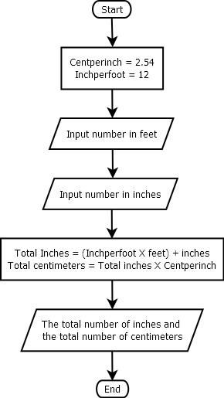
Pseudocode:

import java.util.*;

public class Conversion{
// variable declaration
static Scanner console = new Scanner (System.in);
static final double Centperinch = 2.54;
static final int Inchperfoot = 12;

public static void main(String[]args){

int feet, inch, tinch;
double tcent;
// input feet
System.out.println ("");
System.out.print("Enter number in feet: ");
System.out.flush();
feet = console.nextInt();
System.out.println ("");
// input inches
System.out.print("Enter number in inches: ");
System.out.flush();
inch = console.nextInt();
System.out.println ("");
// computation for feet to inches to centimeters
tinch = (Inchperfoot * feet) + inch;
tcent = tinch * Centperinch;
System.out.println ("===============================================================================");
System.out.println ("");
System.out.println("The numbers you have entered are " +feet+ " for feet and " +inch+ " for inches");
System.out.println ("");
System.out.println("The total number of inches: " +tinch);
System.out.println ("");
System.out.println("The total number of centimeters: " + String.format("%.2f", tcent));
System.out.println ("");
System.out.println ("");
System.out.println ("");
}

}

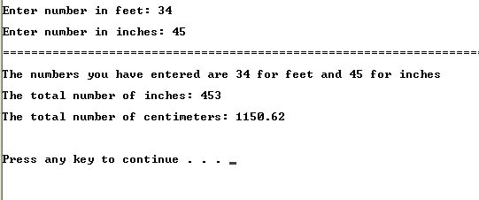
Screenshot:

